**Project Draft**

**Intro**

How do we know if we are using the correct measurements when trying to figure out the development of a nation? Do all countries require the same types of measurement used to calculate their specific development? Economists have been trying to figure out questions like these relating to international development for decades now but ramping up in recent years. More specifically, many wonder if the various indicators we are using today to measure development like GDP and exchange rates really hold a high level of significance when defining the overall fitness of a nation. This is why Economists have developed an indicator used to measure development called the Human development index or HDI for short.

Using data gathered from various Government, Non-profit and private research organizations I took the HDI of various countries and correlated them with a series of economic indicators which all measure considerably different parameters than that of HDI. The Countries I used are the Top 40 nations with the highest HDI scores and the bottom 40 to account for potential differences in the correlation of certain indicators with poorer and richer areas. When doing this I used HDI as the independent variable and four other variables as the dependent variables while running one regression for each variable for each set of country tables.

The results I obtained were that the Gender Inequality index would be best used as an indicator for development when trying to figure out development if tasked with predicting development of a group of rich countries or if you have a group of randomly selected countries. However, when trying to determine the development of poorer countries, GPI or the General Peace Index would be most indicative of development for those less developed areas.

**Background Info.**

For my project I will be analyzing the correlation between various Economic measurements and HDI which is widely used to score the development of a country. Ranking a country’s development is often not easy as many different factors need to be taken into account to make a proper judgment of a country’s well being. And even with the multidimensional approach that needs to be taken, a country could be performing very well based on one metric and completely failing in another which then leads to the problem of how that will be balanced. This problem is why Economists have developed HDI which takes into account social, health and monetary variables and gives a development score of 0-1.

To understand why HDI is so commonly used and reliable to Economists we must first understand what exactly it measures. HDI has three variables being literacy rate, life expectancy and GNI per capita all being equal weights. GNI per capita being Gross National Income being the total amount of money generated by a country’s people and businesses. The decisions to choose these variables were based on the three things Economists deemed people desire to live a cherished life: to be educated and acquire knowledge, to have access to resources so that they enjoy a satisfactory standard of living and to live long and healthy. So to satisfy these social, health and financial aspirations it was concluded that these variables were an adequate representation of what needed to be fulfilled.

The first indicator I will be correlating with HDI is GII or the Gender Inequality Index. GII as described by the UNDP is a measure of the gender inequality of a nation which takes into account labor market and empowerment of that country's inhabitants. And the lower the value a country has, the lower the amount of inequality that nation has and vice-versa. (UNDP) I chose this indicator as Economists have shown many times that the more gender equality a nation has, the higher likelihood it is that other aspects of a country will be highly advanced. This is due largely to the fact that if you have the entirety of a country able to pursue their aspirations rather than just people of one gender, the country will be more economically and socially efficient while at the same maintaining cultural stability. One important thing to remember is this, “The evidence that gender equality, particularly in education and employment, contributes to economic growth is far more consistent and robust than the relationship that economic growth contributes to gender equality in terms of health, wellbeing and rights.”(Kabeer, Natali 2013) In essence this means economic growth is achieved through gender equality not the other way around which means that we simply can’t wait for economic growth to bring us equality. Rather we should use measures to improve gender equality as a catalyst for economic growth.

The next indicator I’m correlating is the Freedom in our world measurement made by Freedom House. This indicator analyzes the political rights and civil liberties of different countries and provides them with a rank. The rankings consist of 210 nations with scores obtained from data via on ground research, information from news articles consulting with NGO's and many other sources. I chose to use this indicator as HDI has no weight or variable that corresponds to the political landscape of a country and I thought this necessary to use as it can show us the bearing that political rights have on a particular country's overall development.

The third indicator I’m using is the Gini index which provides a score for a country's income inequality. This is a crucial thing to measure when deciding the development of a country as it shows you the gap between the rich and the poor and if the gap is significant enough it would be a disservice to call a country developed no matter how high the GDP or GDP per capita is. For this reason many have even called for Economists to make a new HDI that takes GINI into account. Something that is worth mentioning is that many countries' GINI scores took a hit due to the Covid-19 pandemic so this may spike the numbers a bit but nonetheless this will still be a great measurement to correlate.

The final indicator I chose to utilize is GPI or the Global Peace index. GPI measures the peacefulness of a country which is weighted on a scale from 1-5 with a lower score meaning a more peaceful country. However it is structured and takes a variety of metrics into account, “The Index is composed of 23 indicators, ranging from a nation’s level of violent crime and its military expenditure, to its relations with neighboring countries and level of respect for human rights.”(Schippa, 2011). There are many dimensions to what makes a country “peaceful” that many do not think of like political relations, military activities as well as crime rates and more traditional ways people measure peace in an area.

When deciding which measurements to correlate it was important to make sure that the indicators were different than the weights used in HDI to avoid natural correlation which undercuts the whole point of the analysis which is to find the correspondence of two factors that seem to have nothing in common but both move in a similar pace with one another. For example it would make no sense for me to correlate GDP per capita as GNP per capita is already taken as a weight for HDI and the actual values and ways to calculate both are almost identical so to use that would be pointless. Over the course of this project I intend to gain a better understanding of what exactly leads to the development of certain countries and which areas we need to prioritize the repair of to rejuvenate the development of our world's nations.

**Data Description**

For this project I am analyzing the Correlation between HDI and various Economic indicators to figure out which indicator is the best to use for predicting the development of a nation. The indicators are GPI(Global peace index), Freedom in the World score, Gini and GII also referred to as the Gender Inequality Index. To do this I needed to take into account that richer countries have a differing structure to their Economies and face different issues than poorer ones so the most efficient indicator to use for less developed countries could be different from the best one to use for the more developed ones. So knowing this I needed to run my regressions using two separate data tables. One with the top 40 countries who ranked the highest in HDI as well as their data for the other indicators and one with the bottom 40 countries in HDI. So in essence, I had to compile data from two separate groups of countries and run 2 different regressions for each indicator with HDI as the independent variable and figure out what the correlation coefficient is at each indicator amongst the 2 groups.

For GII and HDI my data was from the UNDP or the United Nations Development Program, the Freedom scores were from an organization called Freedom House, Gini Coefficients were from the world bank and the GPI was from the Vision Of Humanity group. And the data that I gathered from these indicators of the two groups is as follows:

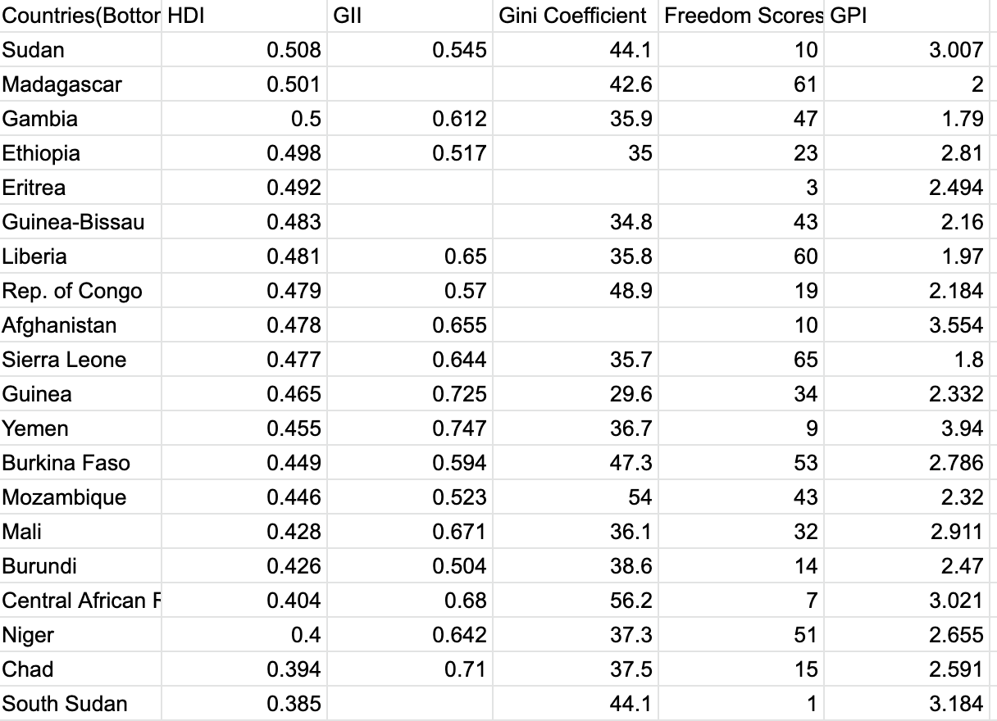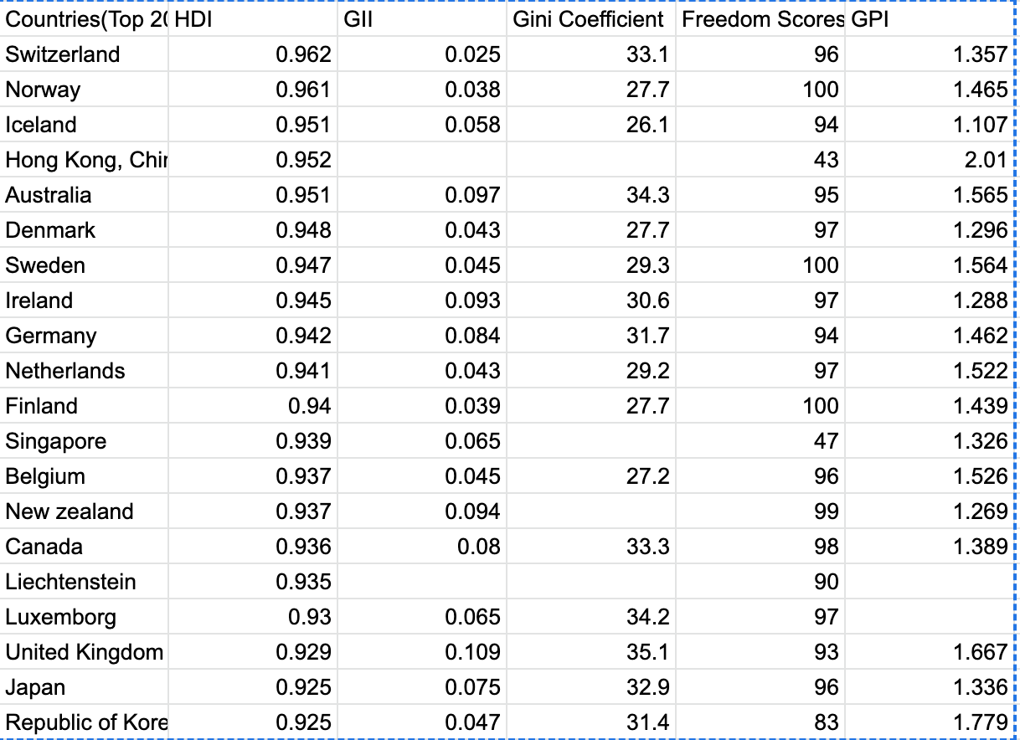

HDI is measured on a scale from 0-1 with the closer to one the more developed, GII is the same except that the lower the score means there is more gender equality, Gini goes from 0-100 with the lowest values having more income inequality, Freedom Scores also go from 0-100 with higher numbers meaning more freedom for its citizens and finally GPI goes on a scale from 1-5 with 1 being the most peaceful a country can get and 5 being the most dangerous.

However, there were a few problems that were presented when I gathered this data. One of these problems was missing data due to the fact that a lot of the ranks/scores on various indicators were either undetermined or unreported. And while I noticed this I couldn’t help but notice as well that most of the countries with missing data also had missing Freedom scores. To provide context, the freedom scores rate a country based on its citizens' access to political rights and civil liberties. I think this may be due to the fact that countries with lower scores are more likely to be corrupt or have some sort of authoritarian regime that could be less interested/compelled to report data that could bring up concerns about their power. Another problem that I faced was when a country listed on HDI was under a different name on the other data sources that I obtained information from. This happens sometimes when a country maybe goes by multiple different aliases or is even divided into two sects of government for ex. the republic of congo and the democratic republic of Congo. All I needed to do was make sure that the data I gathered was indeed from the same country and I wasn’t adding data to one countries column on my table which was in fact from a completely different one which would significantly reduce the validity of my findings given the quality of the data would be very poor.

**Data Analysis**

To figure out which economic indicator I correlated with HDI was the most accurate measurement in determining a country’s development, a few things needed to be incorporated in my analysis to make sure my results were accurate. First I needed to make sure I had an adequate amount of data. Originally I had 20 data points for the two groups I was running analysis on(Top 40 and Bottom 40 Countries in HDI) but realized my results were malleable to outliers which could shift the outlook of what my conclusions would be. In response to this I doubled the data size to 40 points for each group equalling a total of 80.

In terms of the actual analysis, there were many intriguing results that I gathered. The first indicator I correlated with HDI was GII or the gender inequality index. Prior to running my analysis, I expected the correlation between the gender equality of a nation to be stronger with poorer countries than richer ones. The reason I thought this was because I was under the idea that once a country reaches a certain level of equality, individuals would be able to maximize their utility and any further benefits of increased equality past that point would wane. However, this was wrong and the correlation between GII and development was higher with the Top 20 developed countries than the Bottom 20 by a substantial amount too.

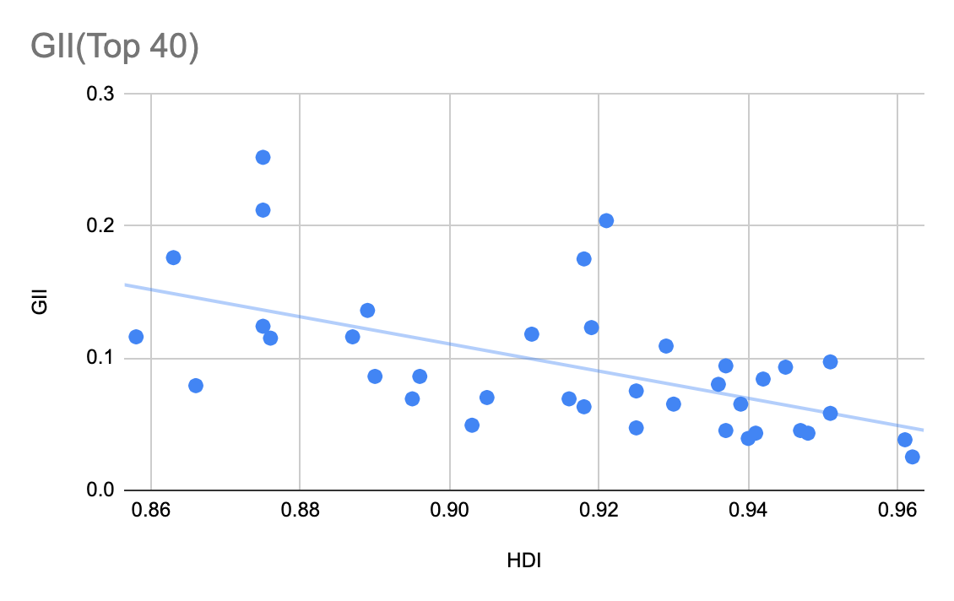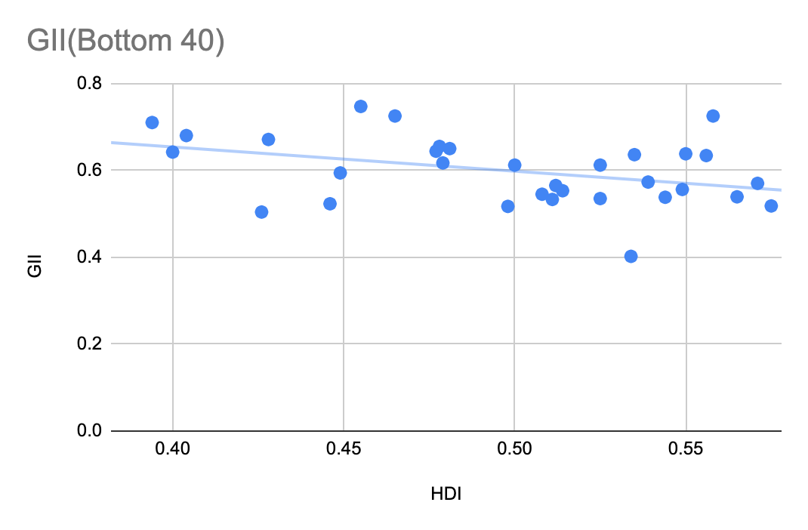

The R^2 value also known as the Coefficient of determination or Correlation coefficient for the top 40 was -.58 and for the bottom 40 it was -.4. These are both fairly strong correlations but what these findings show us is that gender equality is more important in determining the development of a nation for a rich country rather than a poorer one.

The next indicator I correlated was the Gini score which measures the income equality of a country. I expected to see less of a correlation as poor countries can have what seems to be a good score but only because a high percentage of their country has a very little money making income equality high but actual development low. So a high score could mean that a country is doing either really well or very bad in terms of their economic health.

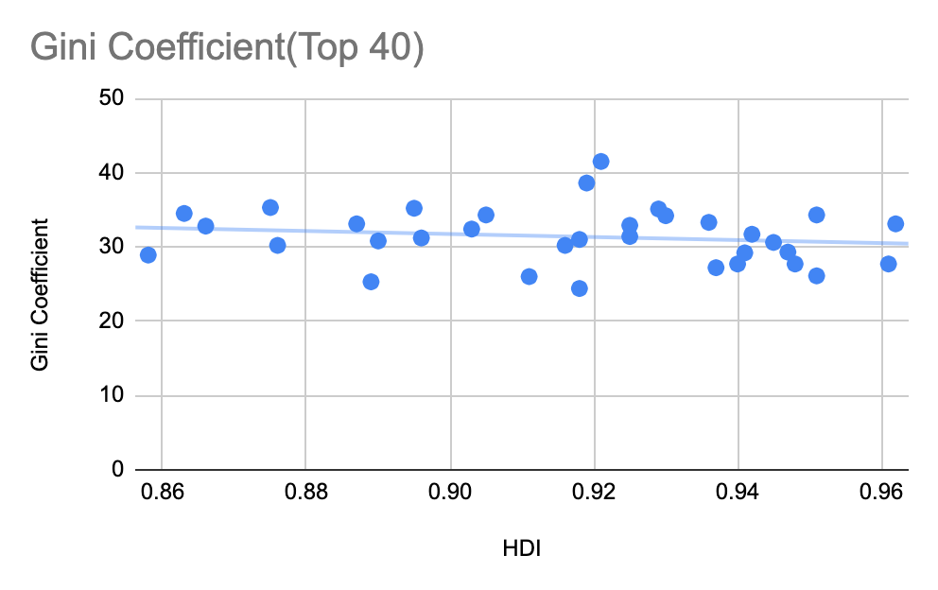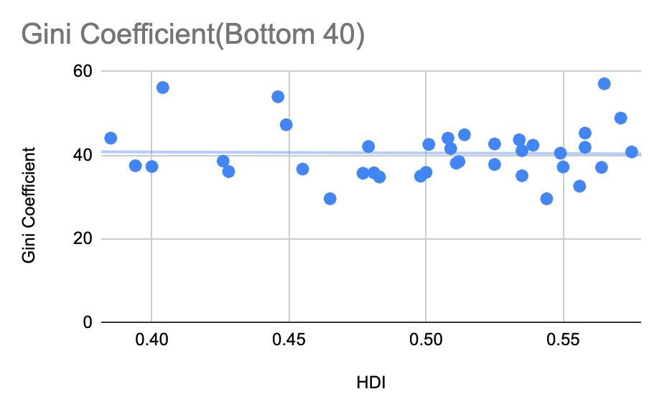

The R^2 of the Top 40 was -.16 and the Bottom 40 was -.02. Both of these as expected had small correlations with the Top 40 having somewhat of a significant correlation but not big enough to really extrapolate any meaning from these findings. Many economists have been thinking about adding the Gini metric into HDI to account for income inequality but based on what I have found here I am a bit skeptical.

The third indicator I analyzed was the freedom scores for each country. What I expected was similar to what I expected the outcome for gender equality would be, once a country reaches a certain level of political/civil freedom there was less growth going forward beyond a certain point of development. And this seems to have actually been the case.

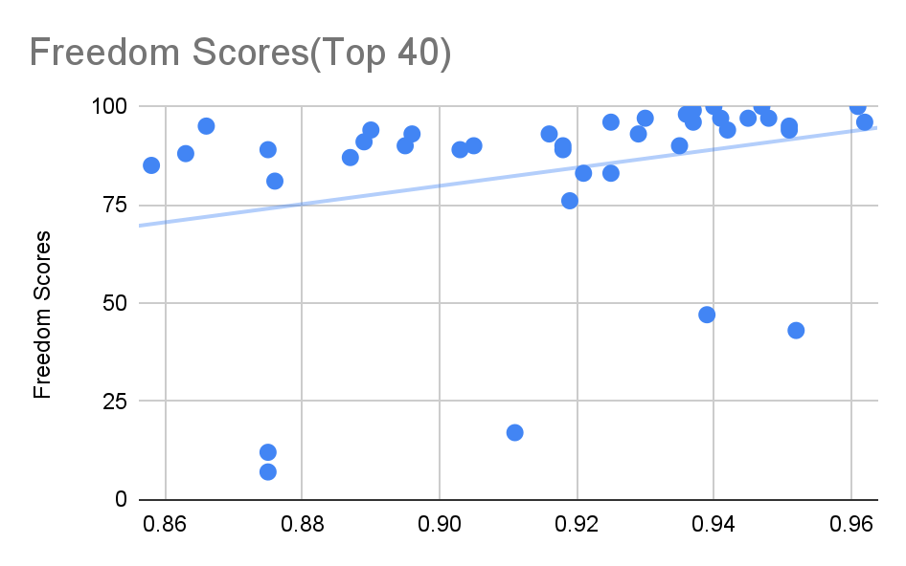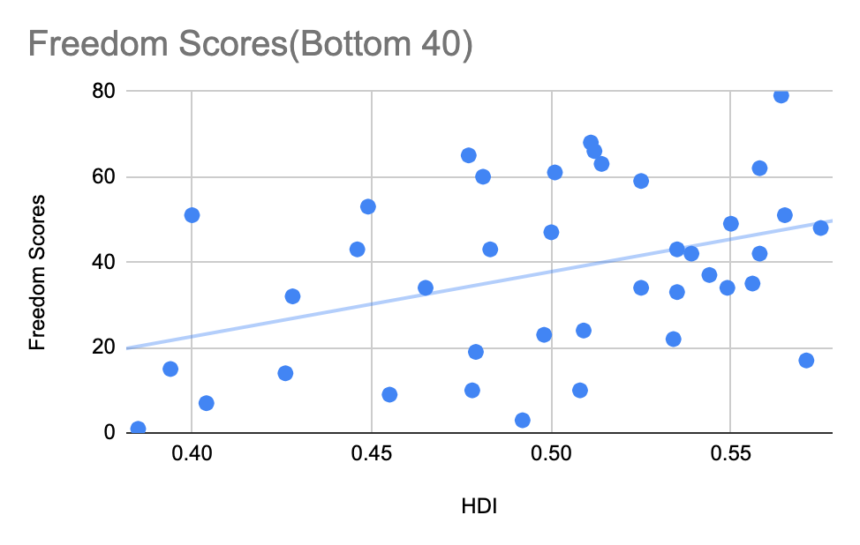

The R^2 of the top 40 was .29 and .39 for the Bottom 40. This proves my original hypothesis that Freedom scores for poorer countries would be more indicative of development than it would for poorer countries. Overall, this shows us that this indicator shows a moderate to strong connection with development of both poor and more affluent countries and should be looked into for measuring development further.

The last indicator I correlated was GPI or the General Peace Index which judges how dangerous a country is based on a variety of metrics. I had originally expected the more developed countries to have a weaker connection as a certain standard of peace was needed to become developed and once you have a certain amount of safety it is you can start to focus on more productive things in your leisure time. So I expected a lot of their scores to fall in a high range.. And that's exactly what happened.

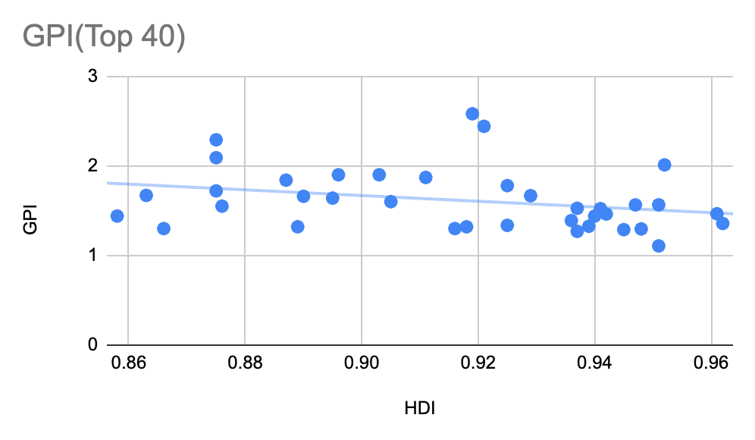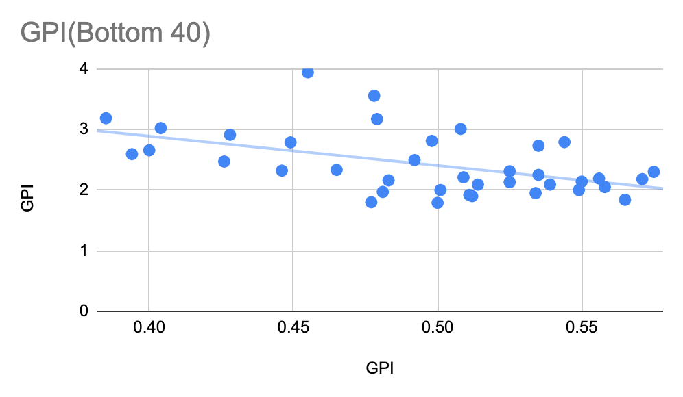

The R^2 of the top 40 is -.29 and the bottom 40 is -.5. This seems to show a strong correlation for the bottom 40 and a moderate correlation with the Top 40 making this indicator very useful in predicting development of poorer countries.

Another significant finding that speaks to the validity of my results is the values I obtained from the P-scores of each of my variables. For all of the variables I correlated for each group the corresponding P-score was below .001. Due to the fact that the P-scores are below .05 the results I obtained should be considered statistically significant and the null hypothesis should be rejected.

With the analysis provided above I was ready to answer my question. However, I realized to provide an accurate conclusion there must actually be multiple answers to what the best indicator will be. One for the indicator that showed the highest average correlation values taking both the top and bottom countries in HDI into account, one for the top countries in HDI and one for the bottom countries. So, the best performing indicator with the highest correlation coefficient averaged out with both groups would be GII having an average correlation of -.49. This would be best used with data from random countries not ordered by development for example. GII also has the highest correlation coefficient with the top 40 so we would use that as the best indicator for richer countries as well. Finally, for poorer countries we would use GPI due to the fact that it had the highest correlation coefficient among the bottom 40 of -.50.

**Conclusion**

The benefits of analysis like this is that it can be used to push for improvements for gender equality in countries where it is relatively vacant. It can help instigate changes to social welfare as a whole due to the fact that most of the measures observed in this analysis that had the highest correlations to development were socially driven especially amongst the poorer countries. This shows us that social welfare inequalities need to be addressed as they are the catalyst for progress among lower developed countries.

**References:**

Camilla Schippa, 2011. "[The Global Peace Index](https://ideas.repec.org/h/pal/palchp/978-0-230-34332-0_10.html)," [Palgrave Macmillan Books](https://ideas.repec.org/s/pal/palchp.html), in: Frank M. Go & Robert Govers (ed.), [International Place Branding Yearbook 2011](https://ideas.repec.org/b/pal/palbok/978-0-230-34332-0.html), chapter 0, pages 112-129, Palgrave Macmillan.

Kabeer, Naila, and Luisa Natalie. “Gender Equality and Economic Growth: Is There a Win‐Win?” *Wiley Online Library*, Wiley, https://onlinelibrary.wiley.com/doi/abs/10.1111/j.2040-0209.2013.00417.x.

“Countries and Territories.” *Freedom House*, Freedom House, https://freedomhouse.org/countries/freedom-world/scores.

“Country Insights.” *Human Development Reports*, United Nations Development Programme, https://hdr.undp.org/data-center/country-insights#/ranks.

“Gini Index.” *Data*, The World Bank Group, https://data.worldbank.org/indicator/SI.POV.GINI.

“Global Peace Index Map " The Most & Least Peaceful Countries.” *Vision of Humanity*, Institute for Economics & Peace, 21 Oct. 2022, https://www.visionofhumanity.org/maps/#/.

Nations, United. “Gender Inequality Index.” *Human Development Reports*, United Nations Development Programme, 9 Nov. 2022, https://hdr.undp.org/data-center/thematic-composite-indices/gender-inequality-index#/indicies/GII.

**Data**

| **Countries(Top 40)** | **HDI** | **GII** | **Gini Coefficient** | **Freedom Scores** | **GPI** |
| --- | --- | --- | --- | --- | --- |
| **Switzerland** | **0.962** | **0.025** | **33.1** | **96** | **1.357** |
| **Norway** | **0.961** | **0.038** | **27.7** | **100** | **1.465** |
| **Iceland** | **0.951** | **0.058** | **26.1** | **94** | **1.107** |
| **Hong Kong, China(SAR)** | **0.952** | **0.15** | **38.5** | **43** | **2.01** |
| **Australia** | **0.951** | **0.097** | **34.3** | **95** | **1.565** |
| **Denmark** | **0.948** | **0.043** | **27.7** | **97** | **1.296** |
| **Sweden** | **0.947** | **0.045** | **29.3** | **100** | **1.564** |
| **Ireland** | **0.945** | **0.093** | **30.6** | **97** | **1.288** |
| **Germany** | **0.942** | **0.084** | **31.7** | **94** | **1.462** |
| **Netherlands** | **0.941** | **0.043** | **29.2** | **97** | **1.522** |
| **Finland** | **0.94** | **0.039** | **27.7** | **100** | **1.439** |
| **Singapore** | **0.939** | **0.065** | **44.4** | **47** | **1.326** |
| **Belgium** | **0.937** | **0.045** | **27.2** | **96** | **1.526** |
| **New zealand** | **0.937** | **0.094** | **32.5** | **99** | **1.269** |
| **Canada** | **0.936** | **0.08** | **33.3** | **98** | **1.389** |
| **Liechtenstein** | **0.935** | **0.073** | **31.5** | **90** | **1.376** |
| **Luxemborg** | **0.93** | **0.065** | **34.2** | **97** | **1.34** |
| **United Kingdom** | **0.929** | **0.109** | **35.1** | **93** | **1.667** |
| **Japan** | **0.925** | **0.075** | **32.9** | **96** | **1.336** |
| **Republic of Korea** | **0.925** | **0.047** | **31.4** | **83** | **1.779** |
| **United States** | **0.921** | **0.204** | **41.5** | **83** | **2.44** |
| **Israel** | **0.919** | **0.123** | **38.6** | **76** | **2.58** |
| **Malta** | **0.918** | **0.175** | **31** | **89** | **1.45** |
| **Slovenia** | **0.918** | **0.063** | **24.4** | **90** | **1.32** |
| **Austria** | **0.916** | **0.069** | **30.2** | **93** | **1.3** |
| **United Arab Emirates** | **0.911** | **0.118** | **26** | **17** | **1.87** |
| **Spain** | **0.905** | **0.07** | **34.3** | **90** | **1.6** |
| **France** | **0.903** | **0.049** | **32.4** | **89** | **1.9** |
| **Cyprus** | **0.896** | **0.086** | **31.2** | **93** | **1.9** |
| **Italy** | **0.895** | **0.069** | **35.2** | **90** | **1.64** |
| **Estonia** | **0.89** | **0.086** | **30.8** | **94** | **1.66** |
| **Czechia** | **0.889** | **0.136** | **25.3** | **91** | **1.32** |
| **Greece** | **0.887** | **0.116** | **33.1** | **87** | **1.84** |
| **Poland** | **0.876** | **0.115** | **30.2** | **81** | **1.55** |
| **Bahrain** | **0.875** | **0.212** | **34** | **12** | **2.09** |
| **Lithuania** | **0.875** | **0.124** | **35.3** | **89** | **1.72** |
| **Saudi Arabia** | **0.875** | **0.252** | **45.9** | **7** | **2.29** |
| **Portugal** | **0.866** | **0.079** | **32.8** | **95** | **1.3** |
| **Latvia** | **0.863** | **0.176** | **34.5** | **88** | **1.67** |
| **Croatia** | **0.858** | **0.116** | **28.9** | **85** | **1.44** |
|  |  |  |  |  | **#N/A** |
|  |  |  |  |  |
|  |  |  |  |  |  |
|  |  |  |  |  |  |
|  |  |  |  |  |  |
| **Countries(Bottom 40)** | **HDI** | **GII** | **Gini Coefficient** | **Freedom Scores** | **GPI** |
| **Kenya** | **0.575** | **0.518** | **40.8** | **48** | **2.3** |
| **Rep. of Congo** | **0.571** | **0.57** | **48.9** | **17** | **2.18** |
| **Zambia** | **0.565** | **0.539** | **57.1** | **51** | **1.84** |
| **Solomon Islands** | **0.564** | **0.526** | **37.1** | **79** | **2.25** |
| **Comoros** | **0.558** | **0.51** | **45.3** | **42** | **2.14** |
| **Papua New Guinea** | **0.558** | **0.725** | **41.9** | **62** | **2.05** |
| **Mauritania** | **0.556** | **0.634** | **32.6** | **35** | **2.19** |
| **Ivory Coast** | **0.55** | **0.638** | **37.2** | **49** | **2.14** |
| **Tanzania** | **0.549** | **0.556** | **40.5** | **34** | **2** |
| **Pakistan** | **0.544** | **0.538** | **29.6** | **37** | **2.79** |
| **Togo** | **0.539** | **0.573** | **42.4** | **42** | **2.09** |
| **Haiti** | **0.535** | **0.636** | **41.1** | **33** | **2.25** |
| **Nigeria** | **0.535** | **0.656** | **35.1** | **43** | **2.73** |
| **Rwanda** | **0.534** | **0.402** | **43.7** | **22** | **1.95** |
| **Benin** | **0.525** | **0.612** | **37.8** | **59** | **2.13** |
| **Uganda** | **0.525** | **0.535** | **42.7** | **34** | **2.31** |
| **Lesotho** | **0.514** | **0.553** | **44.9** | **63** | **2.09** |
| **Malawi** | **0.512** | **0.565** | **38.5** | **66** | **1.9** |
| **Senegal** | **0.511** | **0.533** | **38.1** | **68** | **1.92** |
| **Djibouti** | **0.509** | **0.634** | **41.6** | **24** | **2.21** |
| **Sudan** | **0.508** | **0.545** | **44.1** | **10** | **3.007** |
| **Madagascar** | **0.501** | **0.534** | **42.6** | **61** | **2** |
| **Gambia** | **0.5** | **0.612** | **35.9** | **47** | **1.79** |
| **Ethiopia** | **0.498** | **0.517** | **35** | **23** | **2.81** |
| **Eritrea** | **0.492** | **0.65** | **37.63** | **3** | **2.494** |
| **Guinea-Bissau** | **0.483** | **0.583** | **34.8** | **43** | **2.16** |
| **Liberia** | **0.481** | **0.65** | **35.8** | **60** | **1.97** |
| **Dem. Rep. of Congo** | **0.479** | **0.617** | **42.1** | **19** | **3.17** |
| **Afghanistan** | **0.478** | **0.655** | **27.8** | **10** | **3.554** |
| **Sierra Leone** | **0.477** | **0.644** | **35.7** | **65** | **1.8** |
| **Guinea** | **0.465** | **0.725** | **29.6** | **34** | **2.332** |
| **Yemen** | **0.455** | **0.747** | **36.7** | **9** | **3.94** |
| **Burkina Faso** | **0.449** | **0.594** | **47.3** | **53** | **2.786** |
| **Mozambique** | **0.446** | **0.523** | **54** | **43** | **2.32** |
| **Mali** | **0.428** | **0.671** | **36.1** | **32** | **2.911** |
| **Burundi** | **0.426** | **0.504** | **38.6** | **14** | **2.47** |
| **Central African Republic** | **0.404** | **0.68** | **56.2** | **7** | **3.021** |
| **Niger** | **0.4** | **0.642** | **37.3** | **51** | **2.655** |
| **Chad** | **0.394** | **0.71** | **37.5** | **15** | **2.591** |
| **South Sudan** | **0.385** | **0.74** | **44.1** | **1** | **3.184** |

**Summary Statistics**

**HDI Top 40(2021)**

Mean: 0.9172475

Median: 0.923

Sum: 36.6898

Maximum: 0.962

Minimum: 0.858

Range: 0.1049

Standard deviation: 0.02955670766422941

Variance: 0.0008735989679487174

Datapoints: 40

**HDI Bottom 40(2021)**

Mean: 0.49945

Median: 0.5085

Sum: 19.978

Maximum: 0.575

Minimum: 0.385

Range: 0.189

Standard deviation: 0.052607

Variance: 0.0027675

Datapoints: 40

**GII Top 40(2021)**

Mean: 0.09515

Median: 0.082

Sum: 3.806

Maximum: 0.252

Minimum: 0.025

Range: 0.227

Standard deviation: 0.0520002712024486

Variance: 0.002704028205128205

Datapoints: 40

Regression Analysis:

|  | Slope | Intercept |
| --- | --- | --- |
| Coefficient | -0.9348722637 | 0.9526382121 |
| Standard error | 0.2421775857 | 0.2222434853 |
| Coeff. Determination, Standard error Co | 0.281686993 | 0.04464809969 |
| F stat w/ degrees of freedom | 14.90172895 | 38 |
| Regression SS, Residual SS | 0.02970589339 | 0.07575120661 |

Correlation Coefficient with HDI = -0.5307419269

**GII Bottom 40(2021)**

Mean: 0.5997250000000001

Median: 0.603

Sum: 23.988999999999997

Maximum: 0.74

Minimum: 0.402

Range: 0.33799999999999997

Standard deviation: 0.07629228125758974

Variance: 0.0058205121794871785

Datapoints: 40

Regression Analysis:

|  | Slope | Intercept |
| --- | --- | --- |
| Coefficient | -0.6632288238 | 0.931149636 |
| Standard error | 0.210379644 | 0.1056408976 |
| Coeff. determination, Standard error Co. | 0.2073171456 | 0.06911728567 |
| F stat w/ degrees of freedom | 9.93846592 | 38 |
| Regression SS, Residual SS | 0.04747803122 | 0.1815335688 |
|  | Slope | Intercept |

Correlation Coefficient with HDI = -0.455320926

**Gini coefficient Top 40(Most recent)**

Mean: 32.35

Median: 32.05

Sum: 1294.0

Maximum: 45.9

Minimum: 24.4

Range: 21.5

Standard deviation: 4.721581655900207

Variance: 22.293333333333333

Datapoints: 40

Regression Analysis:

|  | Slope | Intercept |
| --- | --- | --- |
| Coefficient | -21.74381546 | 52.29397113 |
| Standard error | 25.70442615 | 23.58864566 |
| Coeff. determination, Standard error Co. | 0.01848289337 | 4.738893478 |
| F stat w/ degrees of freedom | 0.7155758605 | 38 |
| Regression SS, Residual SS | 16.06976681 | 853.3702332 |

Correlation Coefficient with HDI = -0.1359518053

**Gini Coefficient(Bottom 40)**

Mean: 40.14325

Median: 38.55

Sum: 1605.7299999999998

Maximum: 57.1

Minimum: 27.8

Range: 29.3

Standard deviation: 6.479763523502445

Variance: 41.98733532051282

Datapoints: 40

Regression Analysis:

|  | Slope | Intercept |
| --- | --- | --- |
| Coefficient | 0.247475585 | 40.01964832 |
| Standard error | 19.98093591 | 10.03330914 |
| Coeff. determination, Standard error Co. | 0.000004036897439 | 6.56445666 |
| F stat w/ degrees of freedom | 0.0001534027219 | 38 |
| Regression SS, Residual SS | 0.00661044409 | 1637.499467 |

Correlation Coefficient with HDI = 0.002009203185

**Freedom Scores(Top 40)**

Mean: 83.775

Median: 92.0

Sum: 3351

Maximum: 100

Minimum: 7

Range: 93

Standard deviation: 23.805286527716206

Variance: 566.6916666666667

Datapoints: 40

Regression Analysis:

|  | Slope | Intercept |
| --- | --- | --- |
| Coefficient | 231.4581419 | -128.5241942 |
| Standard error | 125.3066402 | 114.9924109 |
| Coeff. determination, Standard error Co. | 0.0823894416 | 23.10165636 |
| F stat w/ degrees of freedom | 3.411903614 | 38 |
| Regression SS, Residual SS | 1820.886989 | 20280.08801 |

Correlation Coefficient with HDI = 0.2870356103

**Freedom Scores(Bottom 40)**

Mean: 37.7

Median: 39.5

Sum: 1508

Maximum: 79

Minimum: 1

Range: 78

Standard deviation: 20.496653885764392

Variance: 420.1128205128205

Datapoints: 40

Regression Analysis:

|  | Slope | Intercept |
| --- | --- | --- |
| Coefficient | 151.9550029 | -38.19392621 |
| Standard error | 58.19820469 | 29.22388528 |
| Coeff. determination, Standard error Co. | 0.1521126672 | 19.12020509 |
| F stat w/ degrees of freedom | 6.817275281 | 38 |
| Regression SS, Residual SS | 2492.274785 | 13892.12522 |

Correlation Coefficient with HDI = 0.3900162397

**GPI(Top 40)**

Mean: 1.599075

Median: 1.524

Sum: 63.96299999999999

Maximum: 2.58

Minimum: 1.107

Range: 1.473

Standard deviation: 0.33185395208256974

Variance: 0.1101270455128205

Datapoints: 40

Regression Analysis:

|  | Slope | Intercept |
| --- | --- | --- |
| Coefficient | -3.369877291 | 4.690010698 |
| Standard error | 1.739684646 | 1.596487875 |
| Coeff. determination, Standard error Co. | 0.08986853181 | 0.3207299854 |
| F stat w/ degrees of freedom | 3.752209794 | 38 |
| Regression SS, Residual SS | 0.3859812798 | 3.908973495 |

Correlation Coefficient with HDI = -0.2997808063

**GPI(Bottom 40)**

Mean: 2.410625

Median: 2.25

Sum: 96.42500000000003

Maximum: 3.94

Minimum: 1.79

Range: 2.15

Standard deviation: 0.4969530075033923

Variance: 0.24696229166666667

Datapoints: 40

|  | Slope | Intercept |
| --- | --- | --- |
| Coefficient | -4.736980467 | 4.776509894 |
| Standard error | 1.325804676 | 0.6657449997 |
| Coeff. determination, Standard error Co. | 0.2514628605 | 0.4355745585 |
| F stat w/ degrees of freedom | 12.76568415 | 38 |
| Regression SS, Residual SS | 2.421971927 | 7.209557448 |

Correlation Coefficient with HDI = -0.5014607267

References:

“Countries and Territories.” *Freedom House*, Freedom House, https://freedomhouse.org/countries/freedom-world/scores.

“Country Insights.” *Human Development Reports*, United Nations Development Programme, https://hdr.undp.org/data-center/country-insights#/ranks.

“Gini Index.” *Data*, The World Bank Group, https://data.worldbank.org/indicator/SI.POV.GINI.

“Global Peace Index Map " The Most & Least Peaceful Countries.” *Vision of Humanity*, Institute for Economics & Peace, 21 Oct. 2022, https://www.visionofhumanity.org/maps/#/.

Nations, United. “Gender Inequality Index.” *Human Development Reports*, United Nations Development Programme, 9 Nov. 2022, https://hdr.undp.org/data-center/thematic-composite-indices/gender-inequality-index#/indicies/GII.

Kabeer, Naila, and Luisa Natali. “Gender Equality and Economic Growth: Is There a Win-Win?” *IDS Working Papers*, vol. 2013, no. 417, 2013, pp. 1–58., https://doi.org/10.1111/j.2040-0209.2013.00417.x.

Schippa, C. (2011). The Global Peace Index. In: Go, F.M., Govers, R. (eds) International Place Branding Yearbook 2011. Palgrave Macmillan, London. https://doi.org/10.1057/9780230343320_10